COVENTRY UNIVERSITY

**COURSE: M.Sc. COMPUTER SCIENCE**

**MODULE CODE:7026CEM**

**STUDENT ID:13143956**

**SUBMITTED BY**

**: RAJINDER KAUR**

**SUBMITTED TO**

**: Dr . NAZARAF SHAH**

Table of Contents

Part-A 3

1. Introduction 3

2. Use case diagrams 4

3. Application Design 5

4. Evaluation 8

Part-B 12

6. References 16

**7051CEM**

**WEB APPLICATIONS AND AI**

**Java EE e-Commerce Application**

# Part-A

## 1. Introduction

In this project work an e-commerce website is created with the use of the Java programing language in order to satisfy the course work.

In this evaluation, a case scenario involving the creation of an e-commerce web application for a small company selling men's clothing has been provided. Customers should be able to view all of the company's clothing and accessory options in the application that will be created, along with other features like logging in and registering, and if they decide to purchase clothing, they should be able to do so directly from the application. The proprietor of the company is expected to have administrative rights, including the capacity to add items to the web application and the ability to keep track of the many orders submitted by clients. In this project effort, a well-known web application has been developed with the aid of the sophisticated Java programming language in order to satisfy the project work's suggested needs. To maintain the effectiveness of the web application, several sorts of features and activities are incorporated into this application. My SQL is used to establish a high-quality database in order to put together the Web application and complete the coursework.

**LINK TO CODE AND OTHER FILES:** [**RajinderKairway/7051-CODE-AND-FILES (github.com)**](https://github.com/RajinderKairway/7051-CODE-AND-FILES)

**LINK TO DEMO VIDEO:** [**RajinderKairway/7051-VEDIO-DEMO (github.com)**](https://github.com/RajinderKairway/7051-VEDIO-DEMO)

## 2. Use case diagrams

**Figure: Use case diagrams**

(Source: Implemented using Draw.io)

The illustration in the previous image makes it very obvious how the aforementioned procedures are carried out on a shopping site. Customers initially go to the shopping site, after which they enter their credentials to log in. The administrator will verify and grant authorization. On the first page, the Home Page will be displayed. The buyer searches for the needed item up front, selects the items, does the necessary activities, and then adds the clothing to their shopping basket. Here, the payment method will be displayed. The client will enter the account information and supply the payment credentials (Zmezm *et al.,* 2019). The function may now be ended by the buyer. The consumer may modify or change their profile by selecting "manage profile" from this menu. Here, you may alter or change your address, email address, password, phone number, and payment method. The admin can take the necessary action for the clients on the backend. Customers supply the credentials, and the admin will review and record the data after checking it. Clothing categories are being added, and product IDs are being used to identify individual goods. The booking will be shown on the front end, and the history of booking management will be seen on the back end (Syarif, and Nugraha, 2020). The site will provide options for removing items and adding new products. The administrator may also use these options to edit the backend profile. The cloth's availability, cost, size, and brand will be disclosed. Both parties will log out and shut down the website once all necessary actions have been completed.

## 

## 3. Application Design

**Figure: Design of the infrastructure**

(Source: Implemented using Draw.io)

An appropriate use case diagram is presented in the image above. Customers will initially browse the dresses, and different clients’ kinds will check out the range of possibilities. A client will inspect the dress's initial design, and client B will inspect the updated design in accordance with their needs. The combined designs will be looked for by Customer C. The analyst will update the catalogs based on the preferences of the customers (Ehikioya, and Guillemot, 2020). After the consumer makes a choice, the duplicate design and the payment option are displayed. The analyst will maintain a record of the designs. The analysts will pay the designer for creating the clothing. Every selling area has all unique designs, combination designs, and fresh designs.

**ERD diagram**

**Figure: ERD diagram of the e-commerce website**

(Source: Implemented using Draw.io)

A quick overview of the layout of a clothing store is shown in the image above. Every block corresponds to a phase of the procedure. The category ID, category name, and category type are displayed in the category section. The customer ID, order ID, and date are displayed in the shopping order block. The customer block is linked to the shopping order block. The client Id, name, contact information, and address are organized in a customer block. The category block will be the customer block, and the product ID, category ID, and the product name will be displayed in the product section. The seller block contains the seller ID, product ID, and name. Customer ID, order ID, product ID, and payment method are all included in the transaction report block. The consumer will receive the payment id along with the transaction id and date. Following all steps, the admin will give the customer the delivery information. The front end will display the received date.

## 4. Evaluation



**Figure: Index page of the website**

(Source: Implemented with the help of the Eclipse IDE)

The "home page" of the application that was successfully constructed is shown in the above-displayed figure after the program has been run on the server. On the homepage, there are two options: "Login" for users who already have accounts and "New Account" for visitors who want to make an account (Su *et al.,* 2019). The "Registration Page" for the newly created web application is shown in the above figure. The page is intended for new users who want to create accounts on the e-commerce website in order to purchase goods from the company. Users can access this page from the previously shown "Home Page" by clicking on the "New Account" button.

**Figure: Code implementation of the website**

(Source: Implemented with the help of the Eclipse IDE)

The code execution of the above image initializes to meet the requirements of the project work.

**Figure: Java code initialization**

(Source: Implemented with the help of the Eclipse IDE)

The above image is implemented with the help of the Java programming language in the plot of the Eclipse IDE.

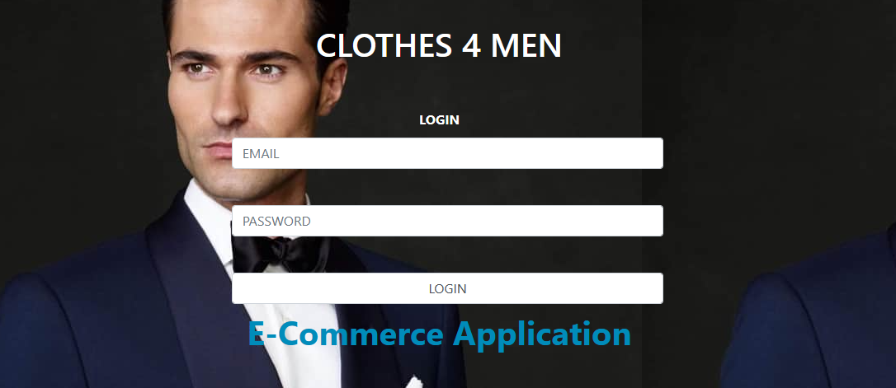

**Figure: Login page**

(Source: Implemented with the help of the Eclipse IDE)

The login page for the web application that has been successfully developed and deployed is shown in the previously presented figure (Yu *et al.,* 2021). Users can reach this "login page" by clicking the "login" button on the previously seen "home page" if they already have an account that they may have made in the past.

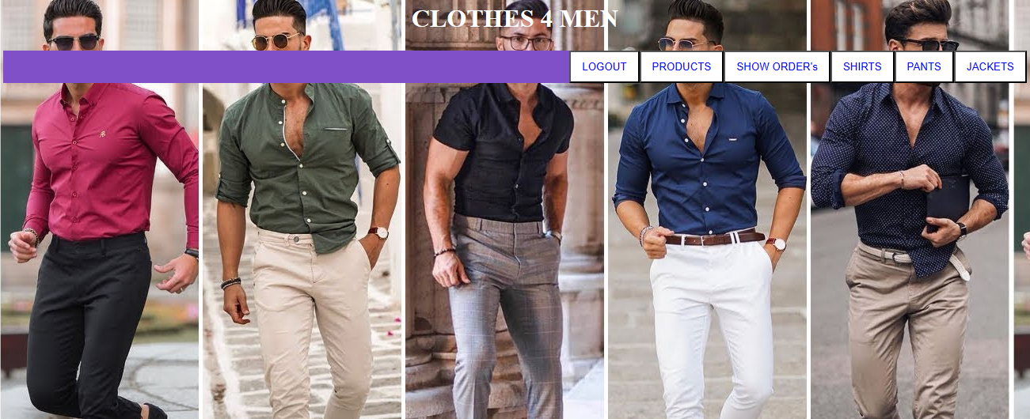

**Figure: Categories of the product**

(Source: Implemented with the help of the Eclipse IDE)

The image above depicts the web page of the program that displays the things that have been made accessible by the company. It is appropriately dubbed "Product Page." Men's shirts, trousers, and coats are among the many goods available on the internet in the image, as can be seen.

**Figure: List of the clothes**

(Source: Implemented with the help of the Eclipse IDE)

This page has been suitably titled "Product Page" in the above picture, which shows the web page of the application that displays the items that have been made accessible by the firm. As seen, the pictured website has a variety of items, including men's shirts, trousers, and coats.

# Part-B

A suitable regression approach has correctly projected the sales value for the year 2024 using the provided sales data and the corresponding budget for the advertisement. Compared to last year, the advertising value has grown by 20%. It spans the years 2016 to 2023. Values are based on annual sales and the price of advertisements. In 2016, there were 12000 sales and 220 expenses associated with advertising. While annual sales were 12445 and advertising costs were 290 in 2017, respectively. In 2018, the annual sales were 12556 and the cost of advertising was 290. In 2019, there were 12500 sales and 200 expenses associated with advertising. While sales were 12787 in 2020 and the expense of advertising was 230. In 2021, the annual sales were 12856 and the cost of advertising was 290. In 2022, there were 275 advertising expenses and 13 010 sales. The cost of advertising is 245 in the last year of 2023, while annual sales are 12378. To analyze the "Forecast1," "Forecast2," "Forecast3," and "Forecast4", all these numbers are entered onto an Excel page.

**Figure: Value of the sales dataset**

**(**Source: Implemented using Excel**)**

The number of sales Using the information provided in the chart described in (Fig). Tap the insert button after choosing the years, advertising expense, and annual sales values, and then choose the scatter chart or bubble chart. This will display a graph in the manner described in (Fig). After that, pick the trendline and add a trend line before picking the chart element. After adding the trend line, choose right-tap on it to open the "format trendline" window, then choose "fill & line" and add the color "blue." Select the right tap on the ruler line, then enter the equation and the "R2" value. "R2 = 0.936" and "y=9.8214x-19573" make up the equation.

**Figure: Forecast values**

(Source: Implemented using Excel)

The function will now perform four evaluations of the four "Forecast" values. The procedure "=FORECAST (x,known_ys,known_xs)" assessed "Forecast1"; press "F4" to lock the value after selecting each value. then hit enter to see the value, "12378.2". When evaluating the "FORECAST2," which is accomplished by using the formula "=FORECAST (known_ys,known_xs,x)", press "F4" to lock each value after choosing it. Then press enter. The value for "Forecast2" is "12346.96," which is nearly identical to "Forecast1." We must ascertain the slope and intercept values before calculating the subsequent "FORECAST3" value (Tan, 2022). The formula to calculate the slope of the graph is "=SLOPE (known_ys, known_xs)" while the formula to calculate the intercept is "=INTERCEPT (known_ys, known_xs)". At this time, the slope is "145.8214" and the intercept is "-93.6786." The equation "y=mx+c" may now be used to solve the third "Forecast3" value. Here, "m" stands for the slope, "c" for the intercept, and "x" for the desired data for 2022. The "Forecast" value is "12292.33" when the slope value and intercept value are included in the calculation. The value of "Forecast4" was then assessed using the equation "y=9.8214x-19573." The value of the year "2022" serves as the "x" variable in this equation. When x is chosen and replaced with the value, "285.8708" is the evaluated value.

**Figure: forecast and sales graph of the data**

**(**Source: Implemented using Excel**)**

The approach is to choose the data of "known_ys, known_xs" along with the "Forecast" data in order to assess the forecast data and sales data graph together and their comparison between them. Then pick "Line chart" from the "insert" menu by tapping on it. The orange line displays the "Forecast" data, and the "blue" lines define the "sales data."

## 

## 5. References

Ehikioya, S.A. and Guillemot, E., 2020. A critical assessment of the design issues in e‐commerce systems development. Engineering Reports, 2(4), p.e12154.

Su, M., Gui, W. and Lu, Q., 2019, December. Design and implementation of B2C China and Laos agricultural products e-commerce platform based on J2EE. In 2019 6th International Conference on Information Science and Control Engineering (ICISCE) (pp. 241-245). IEEE.

Syarif, M. and Nugraha, W., 2020. Pemodelan diagram umlsistempembayarantunai pada transaksi e-commerce. JTIK (Jurnal Teknik InformatikaKaputama), 4(1), pp.64-70.

Tan, L., 2022, October. Construction of Tourism E-commerce Marketing System Based on Data Mining. In Proceedings of the International Conference on Information Economy, Data Modeling and Cloud Computing, ICIDC 2022, 17-19 June 2022, Qingdao, China.

Yu, R., Wu, C., Yan, B., Yu, B., Zhou, X., Yu, Y. and Chen, N., 2021. Analysis of the impact of big data on e-commerce in cloud computing environment. Complexity, 2021, pp.1-12.

Zmezm, H., Zmezm, H.F., Khalefa, M.S. and Alasadi, H.A.A., 2019. Design and Implementation of Challenge Response Protocol for Enhanced e-Commerce Security. In Proceedings of the Future Technologies Conference (FTC) 2018: Volume 2 (pp. 81-93). Springer International Publishing.